Walnut Grove Lake Homeowners Association Construction Request Form

The UNIFIED AMENDED RESTRICTIVE COVENANTS OF WALNUT GROVE LAKE SUBDIVISION, dated 2014, Article 6 Section 1 (q) specifically states: “All plans and specifications for new or future construction of every type including buildings, piers, seawalls, fences, driveways, and walls, shall be submitted in writing to the Association or its authorized representative for its approval before construction begins.”

It is the intent of the WGLHA Board to approve any reasonable request that conforms to the general appearance of the community, is not objectionable to other Association members, and is not in violation of our Association covenants. The Board’s approval in no way is to imply that the owner and/or contractor is in compliance with or can waive any applicable Federal, State and Local codes, ordinances, permits, or other regulations or construction standards, all of which the owner and/or contractor must still comply with.

The owner shall submit plans, sketches, or other suitable documentation with this form, which will all be reviewed and returned to the owner with the Board’s determination. The owner should keep this documentation along with other important legal documents. Likewise, the WGLHA Board will maintain a copy in their files for later review if needed.

Submit construction requests to our WGLHA Managers: Joyce Spiecha at JSpiecha@keithcollinsco.com and Lexie Hatcher at FDering@keithcollinsco.com

If you have any questions about the WGLHA Construction process, contact our Managers or the Homeowner Hotline at https://www.facebook.com/groups/wglha

Lot owner: _________________________________________ Lot number: _________ Phone number: ___________________

Physical street address: _________________________________________ email address: ________________________________

Submission date: ______________ Start date of project: ______________ Completion date of project: ______________

1. Describe the Construction Project (NOTE: Landscaping and/or Repair projects that do not alter the size, shape, or color of any permanent structures does not require a WGLHA Construction Request):

____________________________________________________________________________________________________________

____________________________________________________________________________________________________________

____________________________________________________________________________________________________________

____________________________________________________________________________________________________________

2. Will the work require a Contractor? (NOTE: Seawall, Dock, or Pier construction requires a Contractor.) ______________

3. Contractor Contact Info (if applicable): _____________________________________________________________________

___________________________________________________________________________________________________________

4. Please attach any Construction Request supplemental information to support your request such as: sketches, blueprints, maps, building permits, contractor project descriptions, etc. for review. This additional information will help expedite your construction request through the approval process.

APPROVAL: This Construction Request was approved by at least 3 members of the WGLHA Board on: __________________

Approval Processed by: ______________________________________

Frequently Asked Questions (FAQs)
Updated 05 MAY 2023

*NOTE: This FAQs section does not need to be submitted as part of the Construction Form/Application.

Q: How do I fill out the form electronically, using Adobe Acrobat Reader (Free Software)?

A: Open up the form in Adobe Acrobat Reader and select the “Sign” tab in the upper left corner of the screen. A “Fill & Sign” bar will appear. Selecting the IAb icon on the “Fill & Sign” will allow you to insert text onto any of the available information lines.

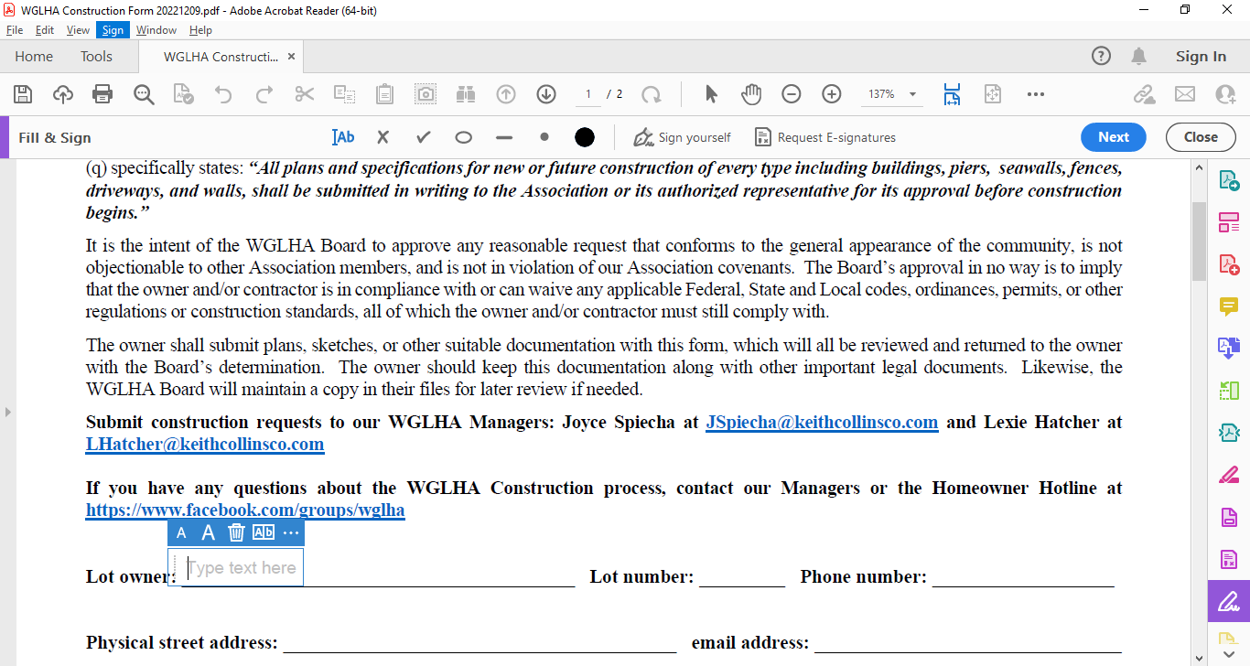

Q: What kinds of construction/home improvement projects require a Construction Request?

A: Any addition of permanent structures on the homeowner property – or – any significant modification to permanent structures on the homeowner property which involves a change in the structure’s exterior size, shape, and/or color.

Q: Beyond the HOA construction request, what other city/county/state agencies are involved with the construction permit process?

A: The short answer is, your contractor is responsible for knowing who to file permits with.

A: The City of Memphis/Shelby County have a joint division of planning and development at: https://www.develop901.com/

A: If you construct a dock with pilings or a sea wall which penetrates the lakebed you will need to request a permit through the Tennessee Department of Environment and Conservation (TDEC). Typically, these request are handled by your dock/sea wall contractor.

Q: What are the HOA limitations on constructing Storage Sheds?

A: A homeowner may construct one Storage Shed with a maximum 120 square foot base and a maximum height of 9 feet. Reference WHGLA Covenants Article 6, Section 1(a).

Q: What are the HOA restrictions regarding home additions?

A: Here’s the most important criteria the Board considers for home addition requests:

- The added structure is “Attached” to the main house. For HOA purposes, “Attached” means the main house and addition are connected by a wall, roof, foundation, deck, permanent walkway, and/or permanent driveway.

- The added structure matches the architectural style and color of the main house.

- The added structure is minimally equipped with electrical power.

Q: Are there any special considerations I need to be aware of when building a dock on Walnut Grove Lake?

A: Yes. There are several.

- For HOA construction requests, the term “Dock” represents a structure extending: over, on, or under the surface of Walnut Grove Lake (HOA property).

- For HOA construction requests, the term “Seawall” from an HOA represents a structure that terminates the owner’s property at the edge of Walnut Grove Lake (HOA property).

- Walnut Grove Lake is owned by WGLHA as “Common Property”. Any docks built on Walnut Grove Lake are built on WGLHA property requiring WGLHA approval.

- All dock related construction requests require dimensional drawings of the dock to be built as well as how the dock will be situated on the property relative to any existing dock structures, property/fence lines, and neighboring docks/boats

- If you construct a dock with pilings or a sea wall which penetrates the lakebed you will need to request a permit through the Tennessee Department of Environment and Conservation (TDEC). Typically, these requests are handled by your dock/sea wall contractor.

- Docks will be constructed in a manner that does not interfere or obstruct your neighbors’ ability:

  - to dock their watercraft

  - launch/retrieve watercraft in or out of the lake

  - reasonably navigate in the middle of cove areas

- Docks need to have a reasonable amount of clearance between the dock and fence/property lines to ensure docks do not impact neighbors’ lake access or use of their shoreline.

- The homeowner is responsible for ensuring the dock does not adversely affect neighbors or community’s use of the lake. If a dock creates an obvious problem for the neighbors or community after construction that was not adequately considered or addressed in the construction request, the Board could direct removal or modification of the dock.

